Lab01-BatGoiTin

- Telnet Server
Server machine that runs telnet service.
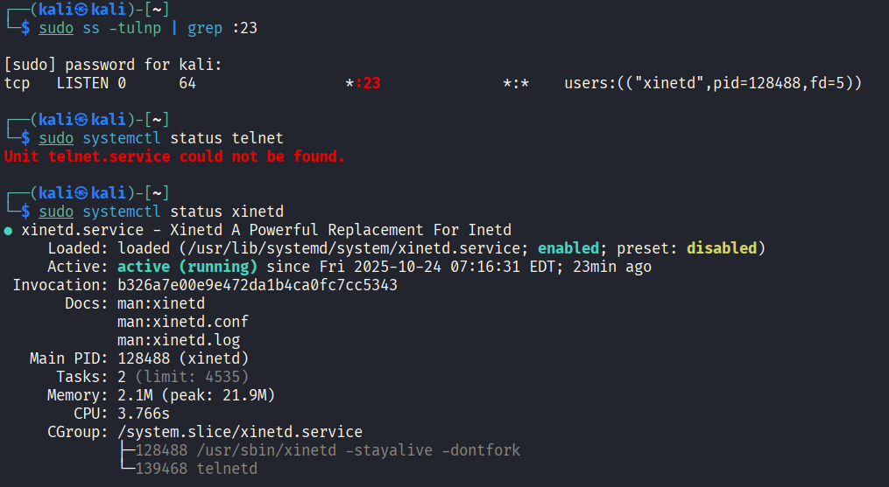

- Victim
Victim that telnet to the server.
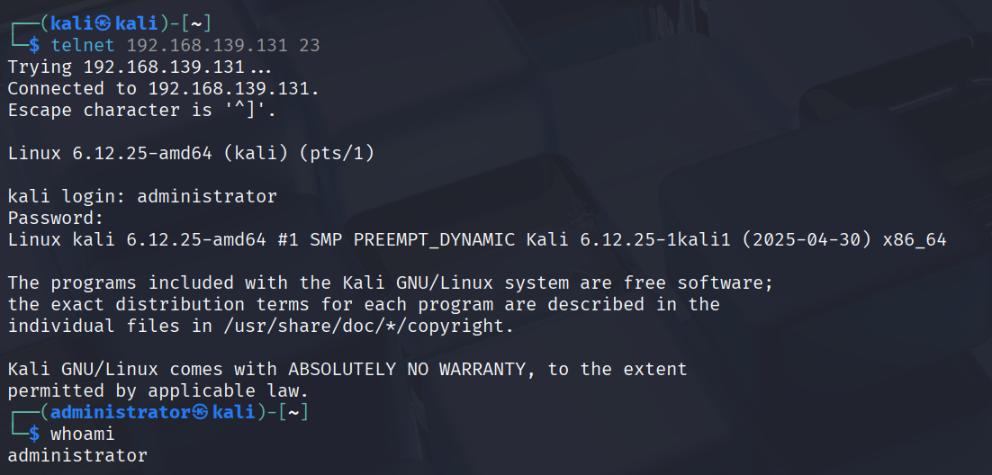

- Attacker
Attacker sniffed the credential packet.
